**How to Install QGIS in Micro Soft Window 10**

1. Run the Setup “QGIS-OSGeo4w-3.4.6-2-Setup-x86.exe” and Click on “Next” Button.

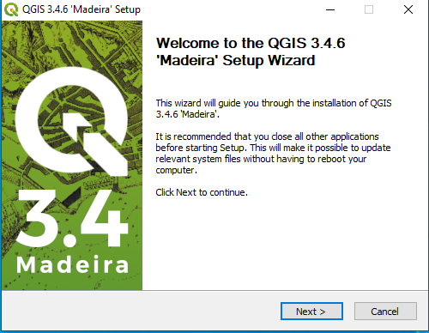

1. Accept the license agreement click on the “I Agree” Button.

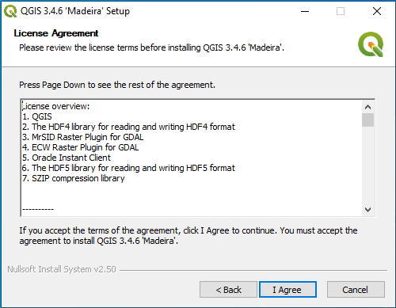

1. “Choose Install Location” (keep it to default) and click on “Next” button.

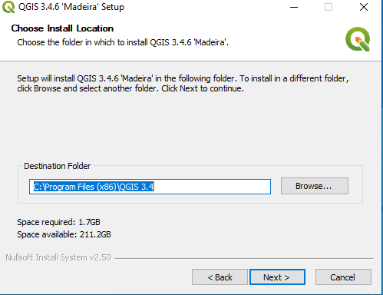

1. “Choose the Components” as user’s requirement and Click on the “Install” button.

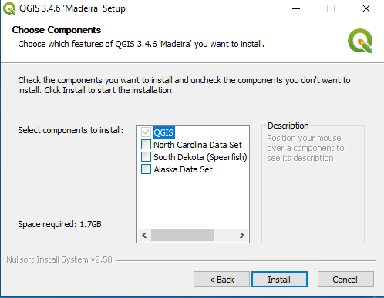

1. The Installer will proceed to complete the installation. Wait a few minute.

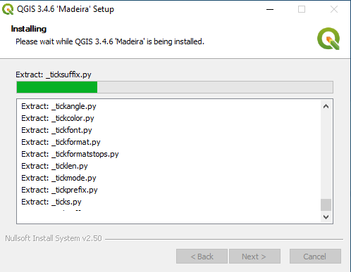

1. After completing the installation “Click on the “Reboot Now” Button.

